

***“It’s hard to study at home and I have no one to help me”. (Tom, 14)***

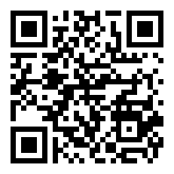

**« The others always mocked me. I got used to it but nothing has changed. » (Mathieu, 14)**

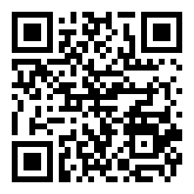

“I found it hard to understand my lessons and no one helped me” (Tassos, 19)

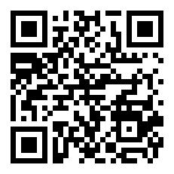

« I do not understand the lessons, nor do I try to. I want to become an **electrician-mechanic** and the school does not provide such knowledge to me”. (Tom, 14)

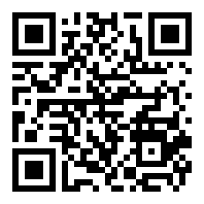

« **I came from a different country. I was hearing remarks about my origin and received indifference** » **(Tassos, 19)**

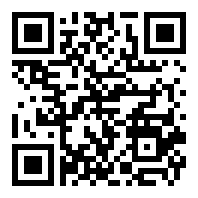

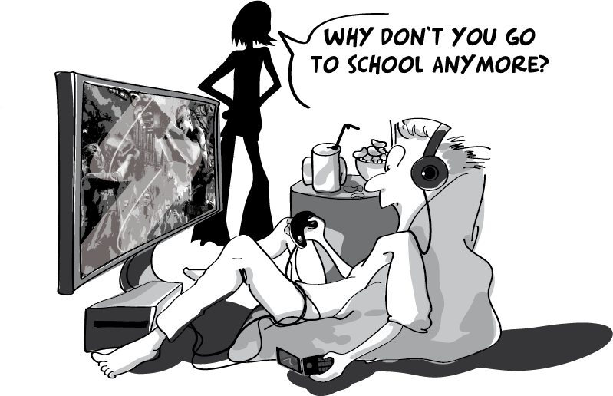

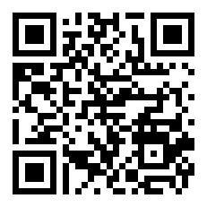

Project Number: 2011-1-IT1-LEO05-01961

CUP: G32F11000680006

