The Learning Game : Workshop n°2

Liège, Belgium
13th February 2008

Activity report

List of Participants

Christine Blaise (tutor) | INFOREF - Liège, Belgium
Christine Cloes | INFOREF - Liège, Belgium
Zlata Selak | INFOREF - Liège, Belgium
Pierre Stegen | Collège Saint-Lambert - Herstal, Belgium
Georges Ferenc | Institut Marie-Thérèse - Liège, Belgium
Laurent Defoy | Institut de la Providence - Herve, Belgium
Mélanie Rahier | INPRES – Institut Provincial d’Enseignement Supérieur – Jemeppe, Belgium
Marie-Laure Mullenders | HELET – Haute Ecole Léon-Eli Troclet – Jemeppe, Belgium

Agenda

- Calendar of the workshops and of the distance teachers meetings

We have submitted the modifications of the calendar for the distance meetings to the teachers. They accepted the calendar but we have also decided to maintain the initial dates planned for the workshops.

- identification of the most efficient tools to produce our pilot course

The teachers involved in the project had explored different games editors before the meeting so that we could choose the most efficient tools to use for the pilot courses.

Finally the workgroup decided that the games editors didn’t offer enough liberty and chose to work mainly with the following tools:
- Adventure Maker
- Adobe Photoshop
- Flash
- 3D Studio Max

However a group of students from the “Institut de la Providence” in Herve (in the area of Liège) started the elaboration of a game with “Hammer” Editor.

They carry on with this project independently of the project realised by teachers.

- A game realised by secondary school students

Students from the “Institut de la Providence” in Herve (in the area of Liège) have realised a game based on the game “CounterStrike”. They have uploaded on their website a pilot version of their game and a serie of documents to help users to make their own versions.

Their website also allows to discuss with the authors of the game:
http://qemiph.free-h.org/learningame/.

Main tool for the development of the game: Hammer 3.4.

Hammer is a program which allows to create maps. This tool is quite simple to use because you only have to place blocks where you want, to choose their size and their texture (color of the block). You can also create more specified blocks as circle, triangle, arc of circle, ... or which have a special function as for example: a scale, lamps, a door, vehicules but these applications are more difficult and are addressed to experienced users.

Game objective

The game can be used simultaneously by several players (max. 32 by server). The main rule is to walk in the school without being catched by other players. The players can walk inside and outside the buildings (in the classrooms). Each time a player enters a classroom, the door locks and to go outside you need to answer pedagogical questions.

The main added value of this game is that it takes place in real infrastructures and that the questions are learning questions.

Work in progress

A draft of the map has already been realised. They still need to put the different elements of the game to real dimensions, to create the pupil who will act in the game, to add finishing details (like luminosity, ...), to conceive the learning questions and the general scenario of the game, ...

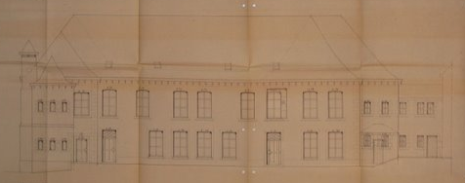

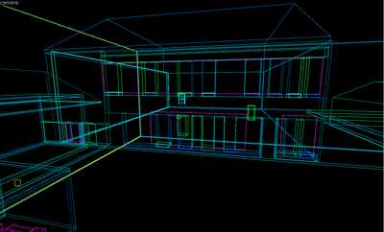

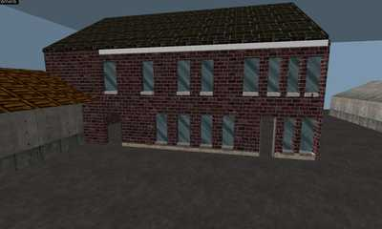

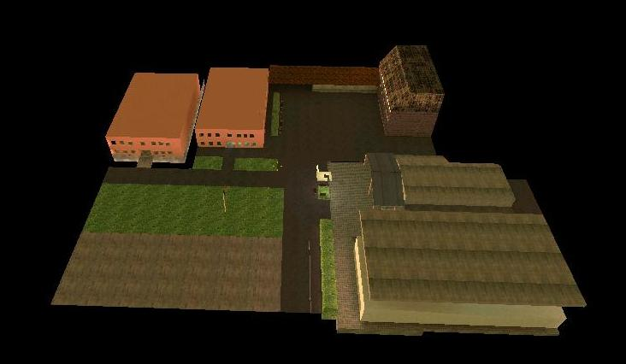

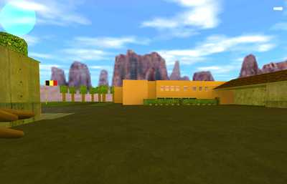

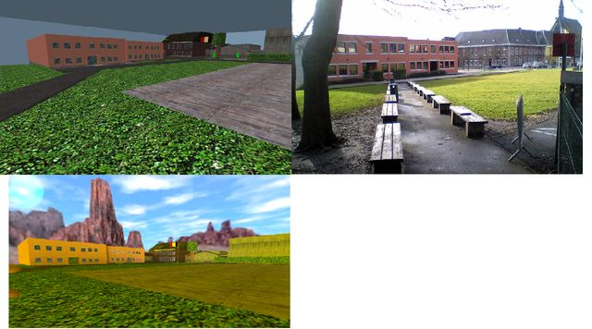

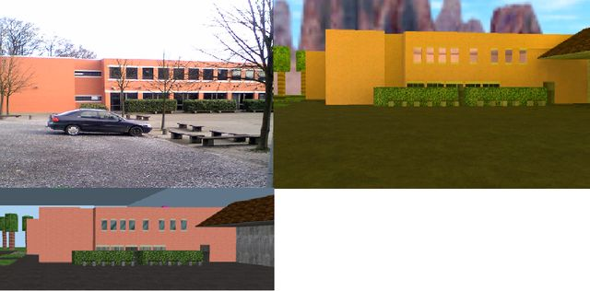

- Creation of a game (pilot course) by teachers

During the previous workshop we had fixed the following tasks:
- To download and test Adventure Maker software: INFOREF bought 5 licences for the participants.
- To think about different learning scenarios in various subjects.

During the second workshop we decided to develop a game which will make teenagers aware of the energy problem. The game would take place in a virtual school realised with 3D pictures. The players (pupils) would have to find energy wastes in the whole school. To remedy this problem the game would give them appropriate tools (insulating material for example).

For the next workshop the teachers will develop the scenario and will begin to produce the first technical elements.

