eLearning Based
History Teaching Sources

Title of Product | City bombing
Image of the product:  Please use jpeg format | 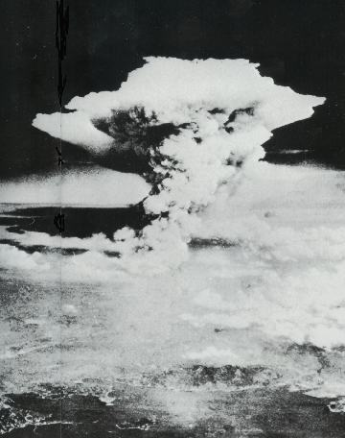
Name of Author(s) | Nezumi Dumousseau
Name of Producer | Nezumi Dumousseau
Date of Production | 1999
Type of product  (CD rom, website, online course etc) | Website
Duration (if relevant)
Language/s of Product | French - English
Cost of Product (€)
Technical requirements:
(e.g. Operating system necessary etc)
Website of the product: | http://nezumi.dumousseau.free.fr/japon/hiroshima.htm
Website of Producer: | http://nezumi.dumousseau.free.fr/japon/hiroshima.htm
Target Group: (Definition and age of target group) | General public

Overall Evaluation:



Tutorial support: NO

If yes, please explain via which method the tutor can be contacted
…………………………………………………………………………………………………………

Availability of learning community

❑ Forum: NO
❑ Chat: NO
❑ Mailing List: NO
❑ Newsgroup: NO
❑ peer to peer: NO
❑ Other (please specify………………………………………………………………….

Objectives & Structure:
Aspects to consider:
- Learning objectives of the product
- Skills required
- Topics covered
- Possibility of constructing a personalised study/training course

This Website describes the preparation, the bombardment and its consequences on Hiroshima and Nagasaki. No specific knowledge is needed to approach theses texts.

Description of contents:

The city: presentation of Hiroshima and Nagasaki as they are nowadays.

Reasons of the bombardment: detailed chronology of the preparation of the bombardments and the manufacture of the bombs.

Facts: in this part, there a link to the real document which gave the order of launching the mission.

Consequences of the bombardment: some pictures show the human consequences of the bombardment. A chart also presents the extent of the bombardment.

Comments:
- How the product could be improved?
- Any other comment

The Website could be improved : adding a forum and / or old articles witch could be downloaded. There are few pictures and almost the whole Website is in French

Evaluation & Comments:

Overall Evaluation: 

Clarity of structure, logical sequence of contents: 

Clarity of instructions for use: 

Usability / easiness of navigation:  Excellent

The product is interesting / stimulating:  Excellent

Educational and learning value: 

Quality and relevancy of content:  Excellent

Compatibility of the content with the target group:  Excellent

Suitability and quality of graphic interface: 

Degree and quality of interaction: Poor

Exploitation of the electronic potential? Poor

Availability and quality of simulation exercises Poor

Quality of the evaluation tools Poor

Possibility of printing/saving material or tests 

Description of how the product was used with the students:
- Is the product suitable to be used with the students?
- If yes, please describe how it was used (e.g. basis for discussion; material for research; exercises; motivation; autonomous learning; group learning; other)
- Evaluate the experience

The vocabulary employed is simple. The facts are reported with a lot of details.

Name of teacher : virginie pucci

Name of School : institut saint-laurent

Subjects Taught: social sciences

Age of Students: 17-18

Date: APRIL 2006

