eLearning Based
History Teaching Sources

Title of Product | JUIN 1944 - UN VENT DE LIBERTE  June 1944 - A wind of Liberty
Image of the product:  Please use jpeg format | 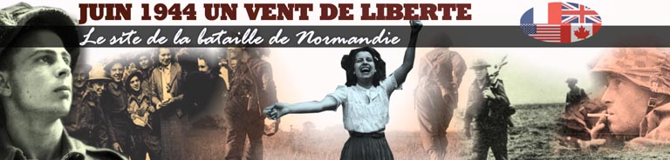
Name of Author(s) | STEPHANE DELOGU, SEBASTIEN DEVIERE, BAPTISTE FLOTTE, PASCAL LHOUTELLIER, IGOR GEILER, MARC ARTIGES, JEAN SECARDIN, CLAUDE MALAGOLI
Name of Producer | JUIN 1944 UN VENT DE LIBERTE
Date of Production | 2006
Type of product  (CD rom, website, online course etc) | Website
Duration (if relevant) | No relevant
Language/s of Product | French
Cost of Product (€)
Technical requirements:  (e.g. Operating system necessary etc) | PC with Internet connection
Website of the product: | http://www.debarquement-normandie.com
Website of Producer: | http://www.debarquement-normandie.com
Target Group: (Definition and age of target group) | General public

Overall Evaluation:



Tutorial support: No

If yes, please explain via which method the tutor can be contacted

Availability of learning community

❑ Forum : yes
❑ Chat : no
❑ Mailing List : yes
❑ Newsgroup: no
❑ peer to peer : no
❑ Other (please specify)

Objectives & Structure:
Aspects to consider:
- Learning objectives of the product
- Skills required
- Topics covered
- Possibility of constructing a personalised study/training course
This website is dedicated to the battle of Normandy. The main topics covered are : the D-Day, the Battle of Normandy, the Atlantic Wall, the Leclerc Division, the witness of veterans, the Memorial of the D-Day and also the Kids’ Zone.
The website contributes also to the Learning community through the Forum 39-45, the visitors’ book, the Links and the MAG’44, online magazine dedicated to the D-Day.

Description of contents:
The website offers a good overview on the events related to the Battle of Normandy, and especially the D-Day, with a lot of pictures. The Kids’ Zone is particularly interesting. The objective of this section is to explain the Landing of Normandy for the children (10-14 years). The discovery of the D-Day is organised as a treasure hunt. The activity is very attractive and the event is clearly explained.

Comments:
- How the product could be improved?
- Any other comment
The interactivity of the website is well developed in the Kids’ Zone but could be improved in the other sections.
The Forum 39-45 is a common forum used by different websites and focused on the World War II. This initiative aims to federate the different websites related to the same topic and thereby to create a virtual community dedicated to the World War II.

Evaluation & Comments:

Overall Evaluation: 

Clarity of structure, logical sequence of contents: 

Clarity of instructions for use: 

Usability / easiness of navigation: 

The product is interesting / stimulating: 

Educational and learning value: 

Quality and relevancy of content: 

Compatibility of the content with the target group: 

Suitability and quality of graphic interface: 

Degree and quality of interaction: 

Exploitation of the electronic potential? 

Availability and quality of simulation exercises 

Quality of the evaluation tools 

Possibility of printing/saving material or tests 

Description of how the product was used with the students:
- Is the product suitable to be used with the students?
- If yes, please describe how it was used (e.g. basis for discussion; material for research; exercises; motivation; autonomous learning; group learning; other)
- Evaluate the experience
The learning material provided by the website is suitable to be used with the students. This material can be used for research or discussion about the D-Day and the World War II. The section dedicated to the children offers a guided exploration of the different events related to the World War II, the Landing and the Battle of Normandy. The presentation and the explanation of the events are suitable for young students (10-14 years).

Name of teacher : Isabelle MARX

Name of School : Institut Marie-José, Liège (Belgium)

Subjects Taught: Social Sciences

Age of Students: 17-18

Date: April 2006

