eLearning Based
History Teaching Sources

Title of Product | The Nuremberg Trial
Image of the product:  Please use jpeg format | 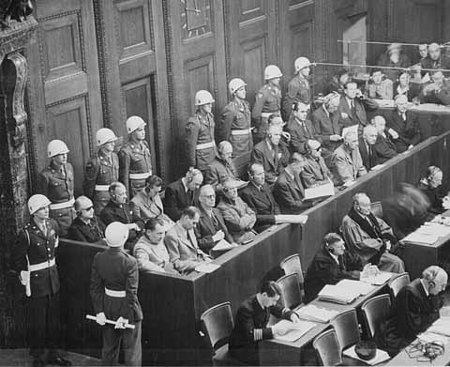
Name of Author(s) | Dominique Natanson
Name of Producer | Dominique Natanson
Date of Production | April 2003
Type of product  (CD rom, website, online course etc) | Website
Duration (if relevant)
Language/s of Product | English, Italian, Deutsch, French
Cost of Product (€)
Technical requirements:
(e.g. Operating system necessary etc)
Website of the product: | http://perso.wanadoo.fr/d-d.natanson/nuremberg.htm
Website of Producer: | http://perso.wanadoo.fr/d-d.natanson/
Target Group: (Definition and age of target group) | General public

Overall Evaluation:


Tutorial support: Yes

If yes, please explain via which method the tutor can be contacted
By e-mail

Availability of learning community

❑ Forum: NO
❑ Chat: NO
❑ Mailing List: NO
❑ Newsgroup: NO
❑ peer to peer: NO
❑ Other (please specify………………………………………………………………….

Objectives & Structure:
Aspects to consider:
- Learning objectives of the product
- Skills required
- Topics covered
- Possibility of constructing a personalised study/training course

Dominique Natanson is the grandson and the nephew of exterminated Jews in Auschwitz in 1942. He tells his family history and the history of Shoah. This site presents in detail the Nuremberg Trial.

Description of contents:

Presentation of the various actors of the Trial: judges, lawyers, marked. The site recalls the history of the creation of the Trial. Documents and testimonies are present. There are also questions asked by Internet users and detailed answers on the website.

Comments:
- How the product could be improved?
- Any other comment

A page of the website is reserved for the pupils. It describes the deportation and the laws into force against the Jews at this time. A paragraph is also devoted to the life in the concentration camps. Students can interact by email to ask questions.

Evaluation & Comments:

Overall Evaluation: 

Clarity of structure, logical sequence of contents: 

Clarity of instructions for use: 

Usability / easiness of navigation:  Excellent

The product is interesting / stimulating: 

Educational and learning value:  Excellent

Quality and relevancy of content:  Excellent

Compatibility of the content with the target group: 

Suitability and quality of graphic interface: 

Degree and quality of interaction: 

Exploitation of the electronic potential? 

Availability and quality of simulation exercises Poor

Quality of the evaluation tools Poor

Possibility of printing/saving material or tests 

Description of how the product was used with the students:
- Is the product suitable to be used with the students?
- If yes, please describe how it was used (e.g. basis for discussion; material for research; exercises; motivation; autonomous learning; group learning; other)
- Evaluate the experience

Dominique Natanson created his website to show to students the life of the Jews during the war. Students can interact and ask precise questions on his Website. Many documents and testimonies are available.

Name of teacher : Virginie Pucci

Name of School : Institut saint-laurent, fleron (belgium)

Subjects Taught: social sciences

Age of Students: 17-18

Date: april 2006

