eLearning Based
History Teaching Sources

Title of Product | Les Archives de Radio-Canada  CBC Radio and Television Archives
Image of the product:  Please use jpeg format | 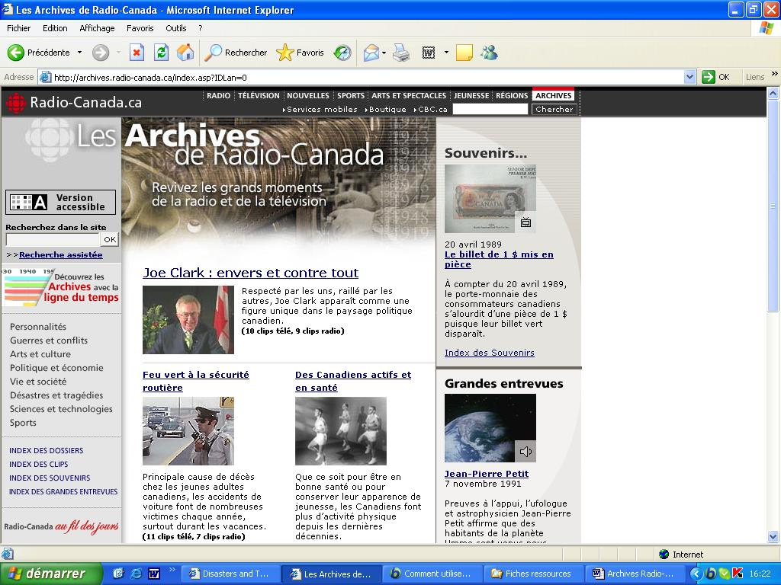
Name of Author(s) | Radio-Canada  CBC (Canadian Broadcasting Corporation) Radio and Television
Name of Producer | Radio-Canada  CBC (Canadian Broadcasting Corporation) Radio and Television
Date of Production | 2006
Type of product  (CD rom, website, online course etc) | Website
Duration (if relevant) | No relevant
Language/s of Product | French - English
Cost of Product (€) | No relevant
Technical requirements:  (e.g. Operating system necessary etc) | PC with Internet connection
Website of the product: | http://archives.radio-canada.ca  http://archives.cbc.ca
Website of Producer: | http://www.radio-canada.ca/index.shtml  http://www.cbc.ca/
Target Group: (Definition and age of target group) | General public

Overall Evaluation:

 Excellent

Tutorial support: Yes

If yes, please explain via which method the tutor can be contacted
e-mail – helpdesk for the teachers

Availability of learning community

❑ Forum: yes
❑ Chat: no
❑ Mailing List: yes
❑ Newsgroup: no
❑ peer to peer: no
❑ Other (please specify)

Objectives & Structure:
Aspects to consider:
- Learning objectives of the product
- Skills required
- Topics covered
- Possibility of constructing a personalised study/training course
During the summer of 2001, the Department of Canadian Heritage approved a joint proposal from the CBC and its French counterpart, Radio-Canada, to create a Web site which would highlight selections from its radio and television archives. Using the latest technology, digital copies of selected programs would be made available online.
In a few short months, technical, editorial and archival teams in Toronto and Montreal, along with assistance from CBC's regional archives across the country, were operating in high gear. Together, they auditioned thousands of hours of programming dating back to the creation of CBC's predecessor, CN Radio, in 1927 and the birth of CBC Television in 1952.
On this Website you'll find a selection of radio and television clips from the Archives of the Canadian Broadcasting Corporation. Some of these files have rested quietly at the bottom of the vaults for more than 60 years and are, for the first time, now accessible to the general public.
In the For Teachers section of the Website, you will find educational materials. These materials were created to complement many of the topics posted on the Web site, and include five lessons per topic, divided by grade level. All educational materials are available free of charge.

Index of Topics : People, Conflict & War, Arts & Entertainment, Politics & Economy, Life & Society, Disasters & Tragedies, Science & Technology, Sports.

Description of contents:
The Archives section of the Website offers to relive our History through CBC Radio and Television. Some of the topics covered are related to the 10 events of the MHM project. For example the World War II and Terrorist attack during Munich's Olympic Games:
http://archives.radio-canada.ca/IDC-0-60-1309-7680/sports/olympiques_histoire_radio-canada/clip4 (French version)
http://archives.cbc.ca/IDC-1-41-1289-7332/sports/olympics_cbc/clip5 (English version)
The goal is not just to present these clips and TV and radio accounts by themselves but to add value to this content by explaining what happened and placing these events in context.
The For Teachers section provides educational material geared toward students. Teachers will find ideas for incorporating CBC's Radio and TV archives into their classroom along with lesson plans and activity sheets, which they can download. All materials are provided at no charge.
The material is presented to complement the topics that we'll find in the rest of the Website. Many but not all of the archival topics have corresponding educational material.

Comments:
- How the product could be improved?
- Any other comment
Excellent source to find audio and video documents related to key events of the 20th century.

Evaluation & Comments:

Overall Evaluation: 

Clarity of structure, logical sequence of contents: 

Clarity of instructions for use: 

Usability / easiness of navigation: 

The product is interesting / stimulating: 

Educational and learning value: 

Quality and relevancy of content: 

Compatibility of the content with the target group: 

Suitability and quality of graphic interface: 

Degree and quality of interaction: 

Exploitation of the electronic potential? 

Availability and quality of simulation exercises 

Quality of the evaluation tools 

Possibility of printing/saving material or tests 

Description of how the product was used with the students:
- Is the product suitable to be used with the students?
- If yes, please describe how it was used (e.g. basis for discussion; material for research; exercises; motivation; autonomous learning; group learning; other)
- Evaluate the experience

This website offers to relive History through audio and video Archives. It’s a very stimulating approach for the students. For the teachers (and their students), the website propose educational material to exploit these Archives.
Students can also use the Archives Quiz, an entertaining way to see what they know about History by using radio and TV clips from the CBC Archives Website.

Name of teacher : Isabelle MARX

Name of School : Institut Marie-José, Liège (Belgium)

Subjects Taught: Social Sciences

Age of Students: 17-18

Date: March 2006

